**TASK 01:**

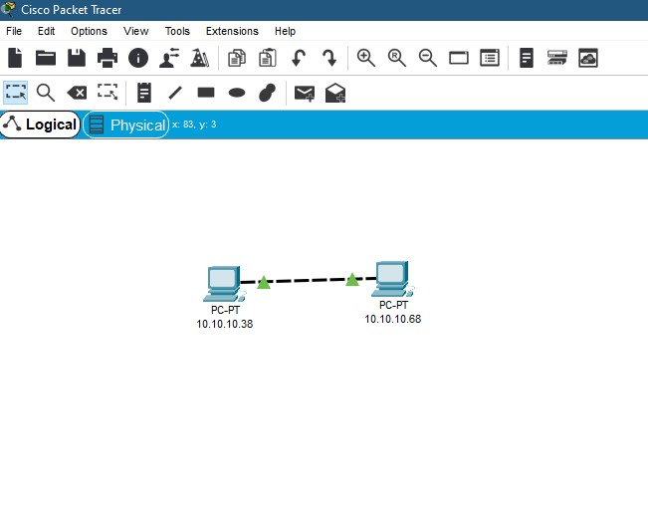

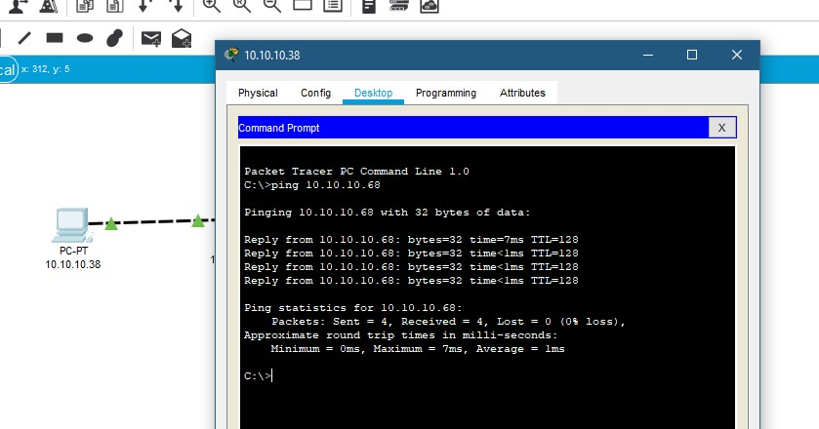

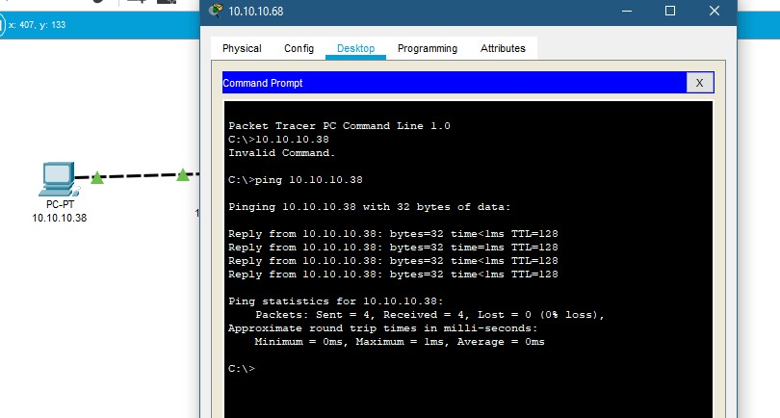

**TASK 02:**

**TASK 03:**

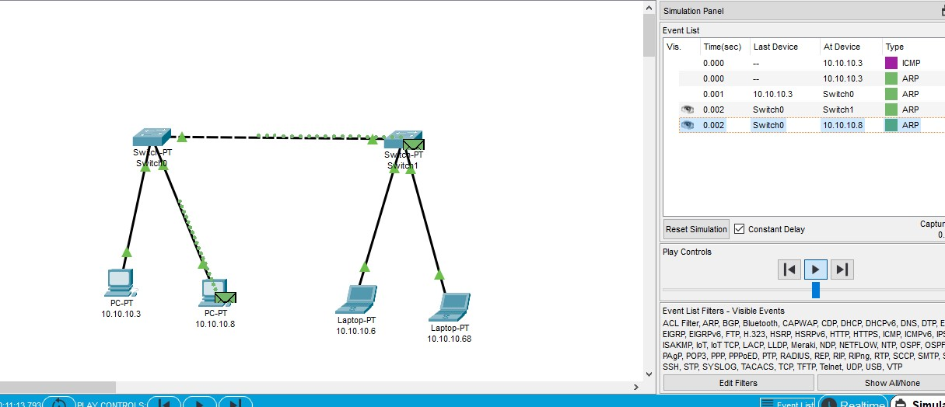

**Identified Devices and their functionality:**

1. **Switches**:
   * + Switches allow devices to connect to each other. When a device sends data, the switch forwards it only to the intended recipient (whether it’s another switch, a router, or a user’s computer).
     + Connected devices can share information and communicate directly with each other.
     + These require no configuration and are typically used for basic connectivity, such as in home networks or small setups.
     + Provide greater security, features, and flexibility.
2. **End PCs (Personal Computers)**:
   * + End PCs allow users to interact with applications, browse the web, create documents, and perform various tasks.
     + End PCs connect to the network (wired or wireless) to access shared resources, servers, and the internet.

**

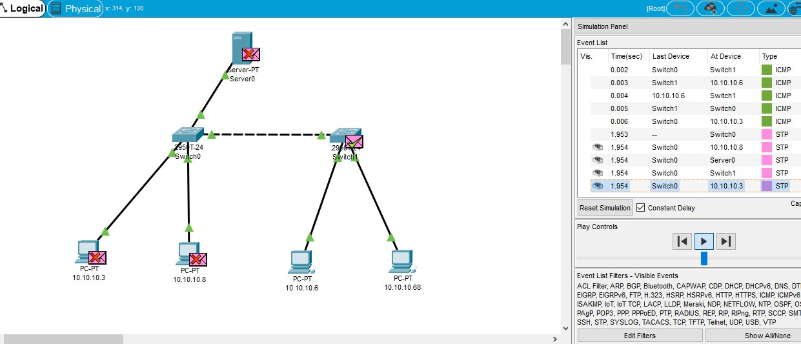

**Identified Devices and their functionality:**

1. **Switches**:
   * + Switches allow devices to connect to each other. When a device sends data, the switch forwards it only to the intended recipient (whether it’s another switch, a router, or a user’s computer).
     + Connected devices can share information and communicate directly with each other.
     + These require no configuration and are typically used for basic connectivity, such as in home networks or small setups.
     + Provide greater security, features, and flexibility.
2. **Servers**:
   * + Servers store files, databases, and applications. They act as repositories for shared data.
     + Servers allow multiple users or devices to access shared resources, such as files, printers, or databases.
     + Servers host services like email, web hosting, domain name resolution (DNS), and file sharing.
     + Administrators manage servers centrally, ensuring security, backups, and updates.
3. **End PCs (Personal Computers)**:
   * + End PCs allow users to interact with applications, browse the web, create documents, and perform various tasks.
     + End PCs connect to the network (wired or wireless) to access shared resources, servers, and the internet.

**TASK 05:**

**Function and Operation:**

* + **Hub**: A hub is a **broadcast** device that transmits signals to **all connected ports** except the one from which the signal was received. It operates at the **physical layer** of the OSI model. Hubs are not intelligent in communication and processing information for the 2nd and 3rd layers.
  + **Switch**: A switch is a **network device** that enables connection establishment and termination based on need. It operates at the **data link layer** of the OSI model. Switches are more sophisticated and provide better connections.

**Transmission Type:**

* + **Hub**: Operates in **half-duplex** transmission mode.
  + **Switch**: Operates in **full-duplex** transmission mode.

**Packet Filtering:**

* + **Hub**: Does **not** provide packet filtering.
  + **Switch**: Provides packet filtering.

**Data Leaks:**

* + **Hub**: Hub basically sends the data to all connected devices.
  + **Switch**: Does not send data to all the connected devices means no **memory/Data leaks** in Switches.